Lab Assignment-1

ECSE373L: Cloud Infrastructure and Services

**Name:** Tanvi Penumudy

**Enroll no**: E18CSE187

**Batch:** EB02

**Lab Activities:**

**Lab Activity 1:** Launch, the AWS Linux instance and connect it using PuTTy.

**Lab Activity 2:** Explore the AWS IAM Service @ Lab Module 4 of AWS Academy Cloud Foundation Course.

**Implementation Screenshots (Step-by-Step):**

**Lab Activity 1**

Choose AMI:

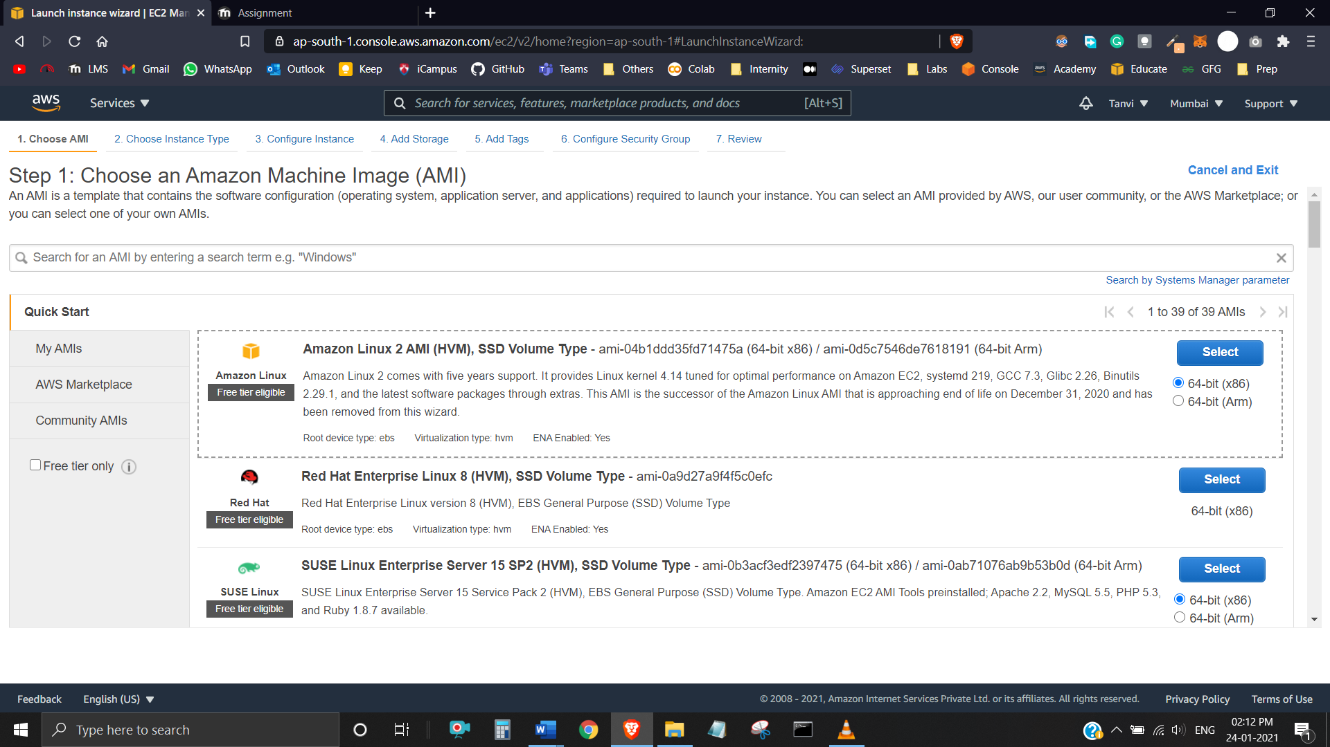

Choose Instance Type: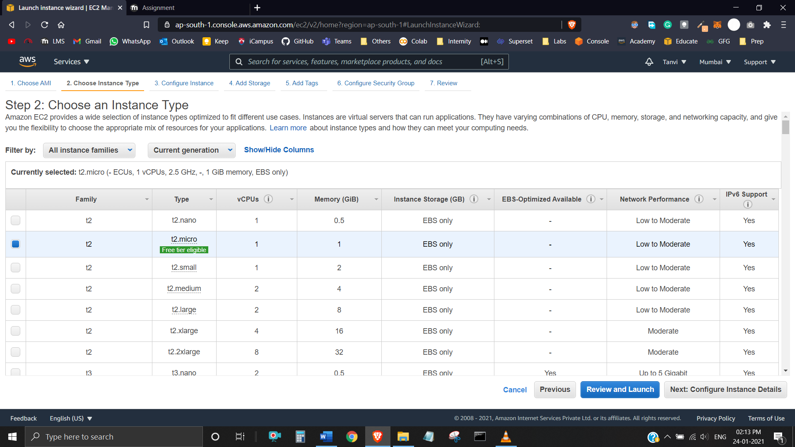

Configure Instance:

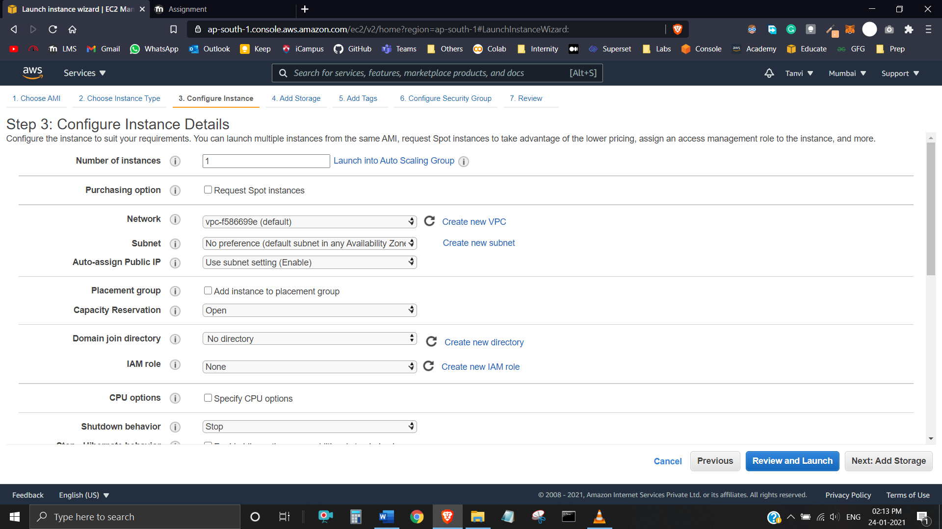

Add Storage: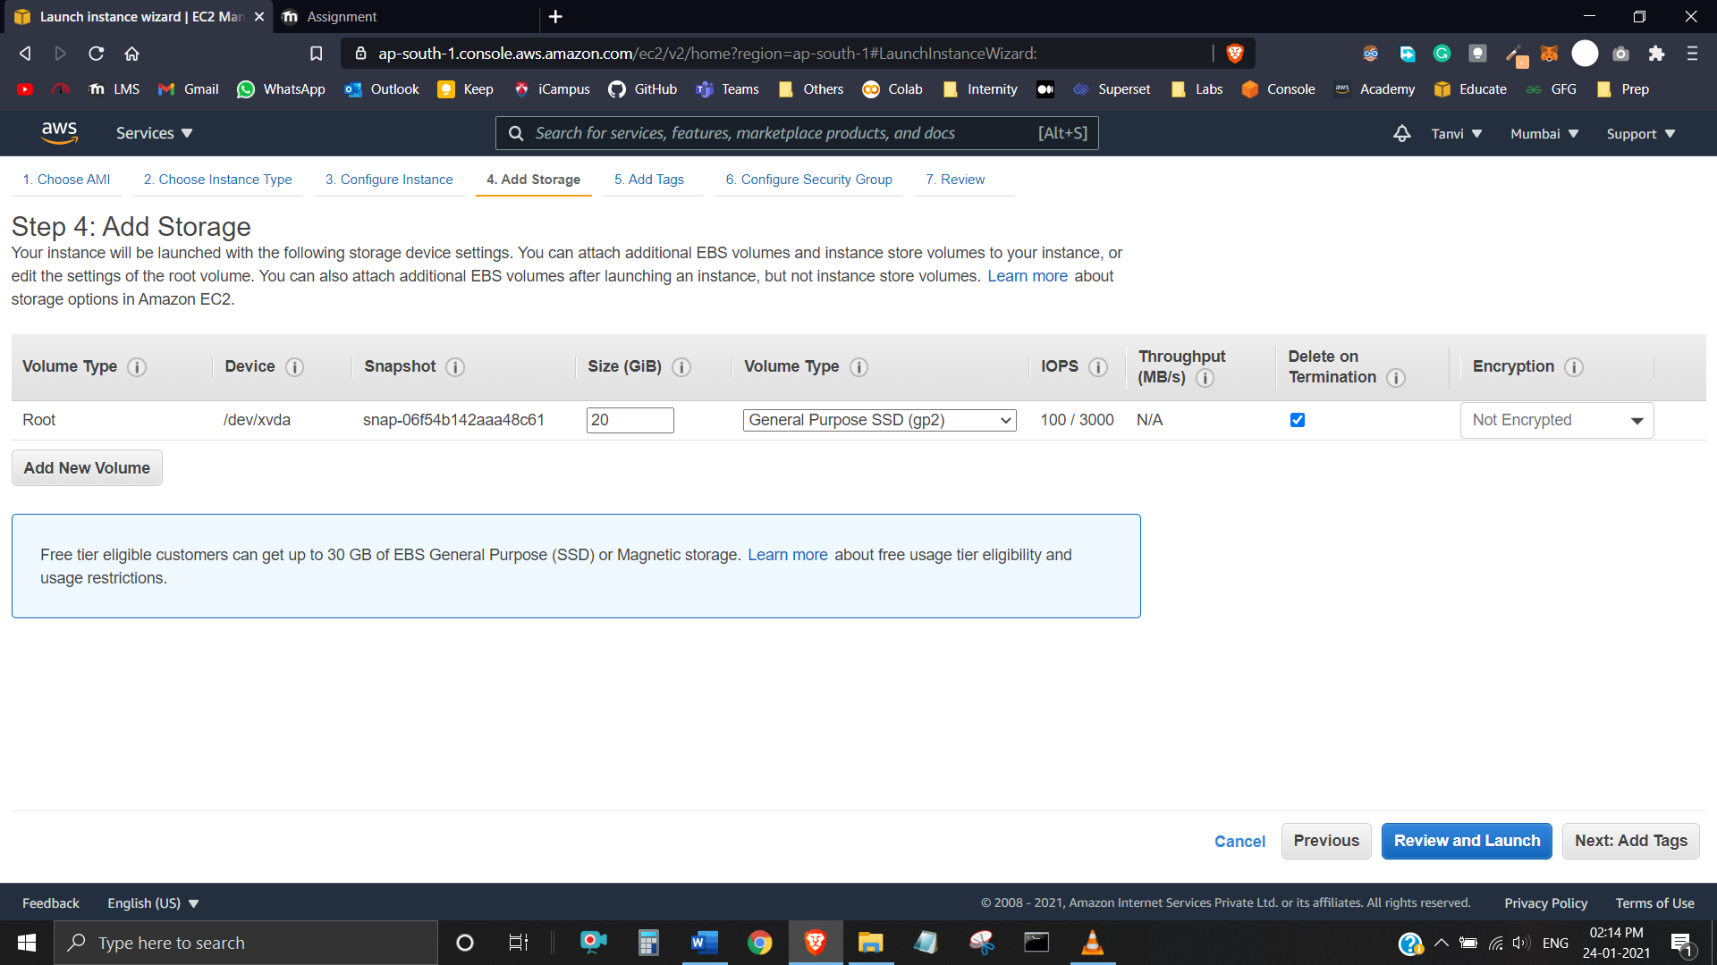

Add Tags:

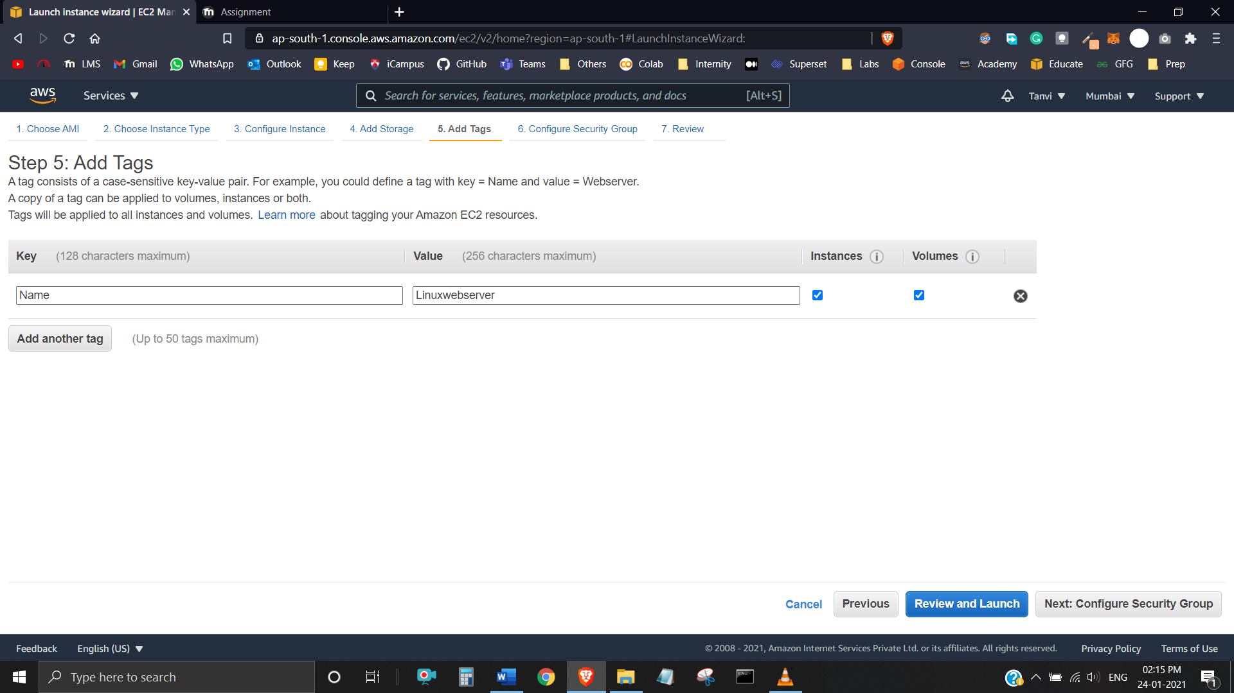

Configure Security Group: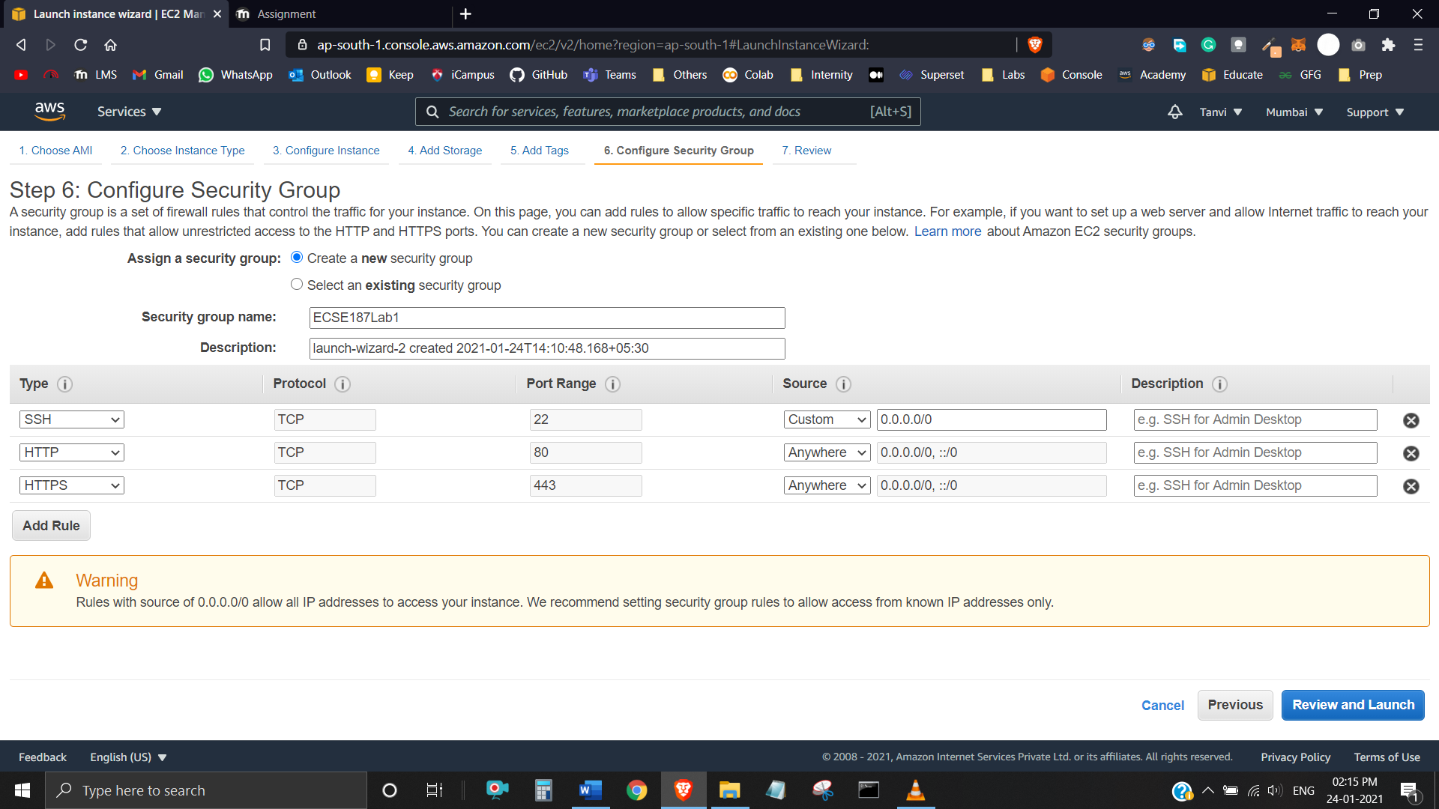

Review Instance Launch:

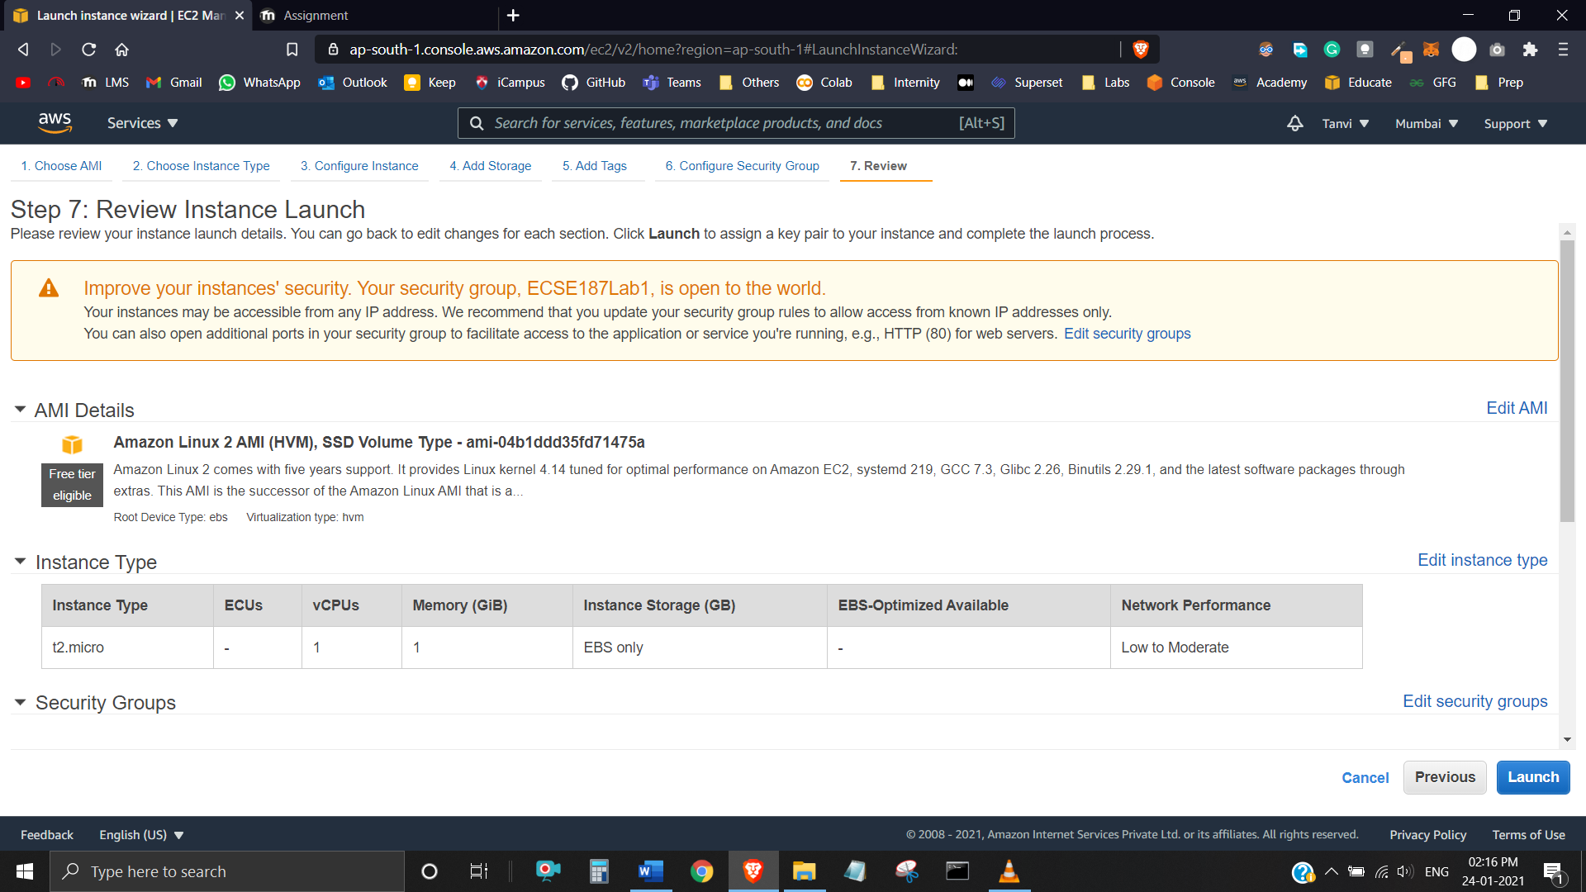

Creating New Key-Pair:

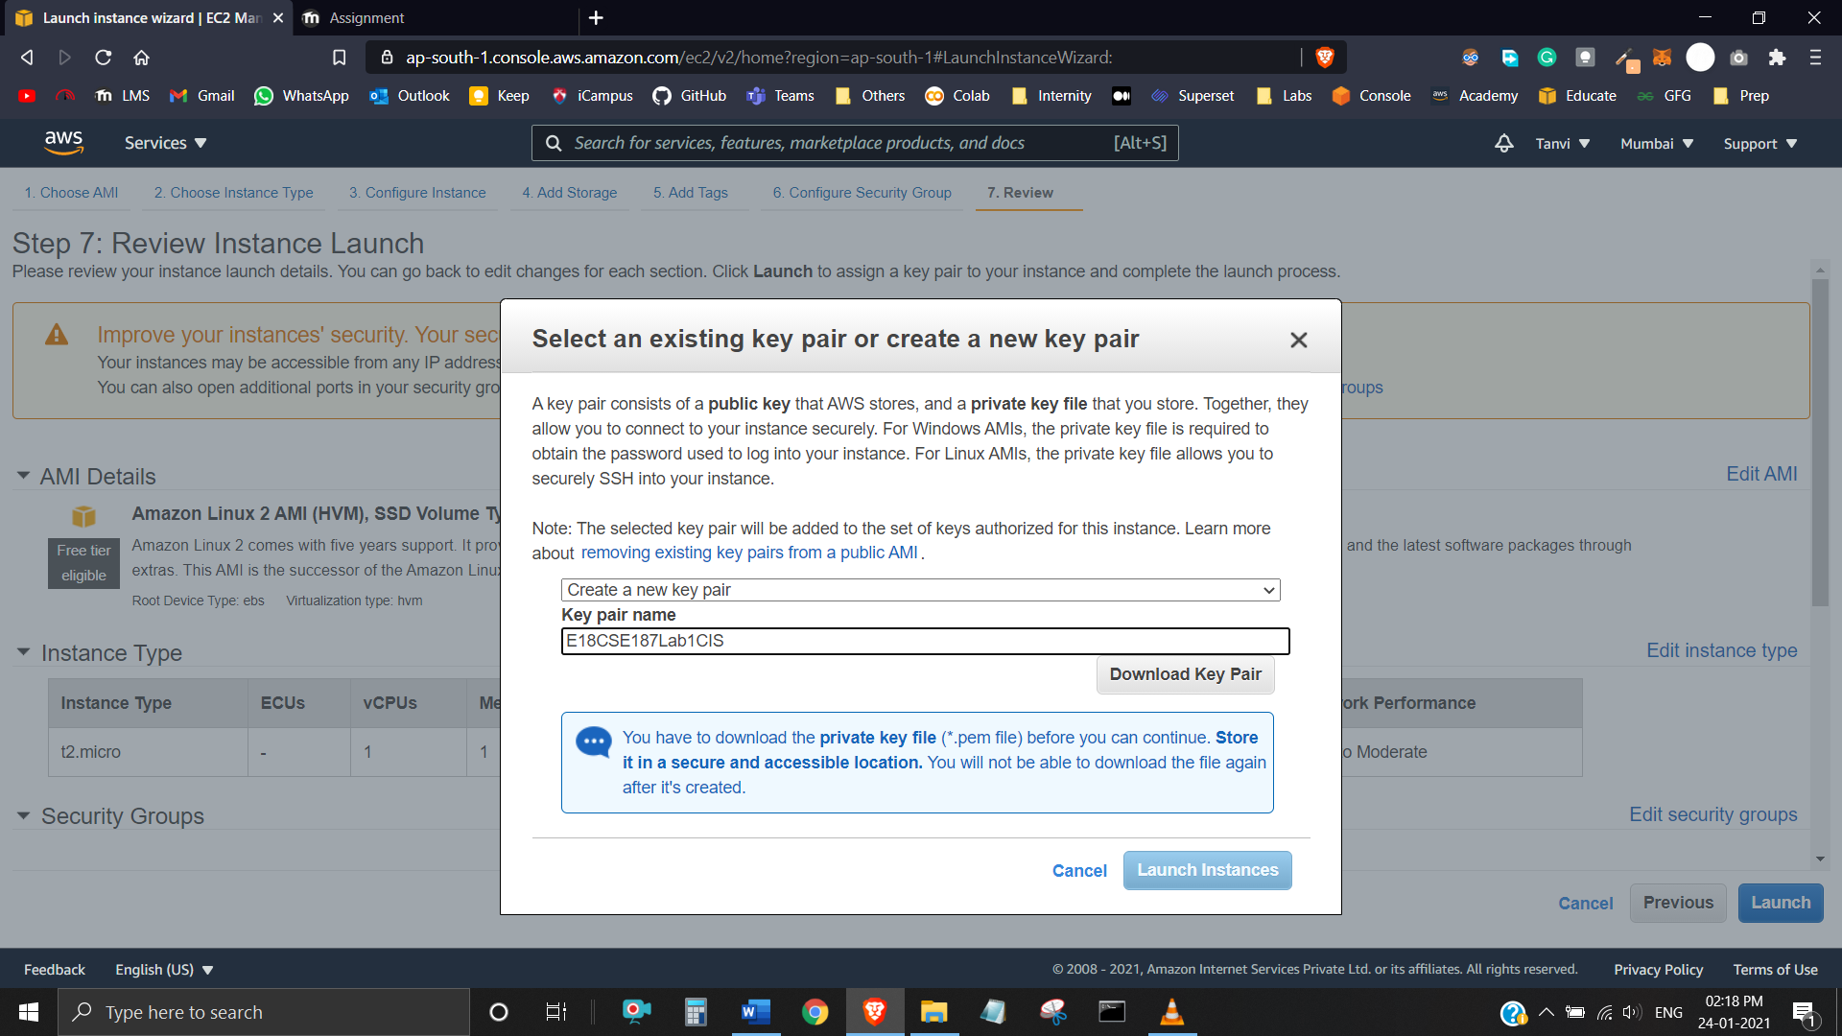

Launch Status:

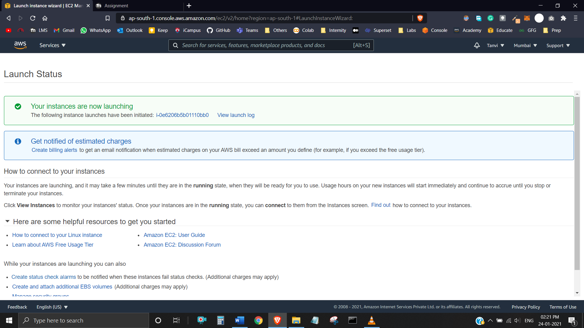

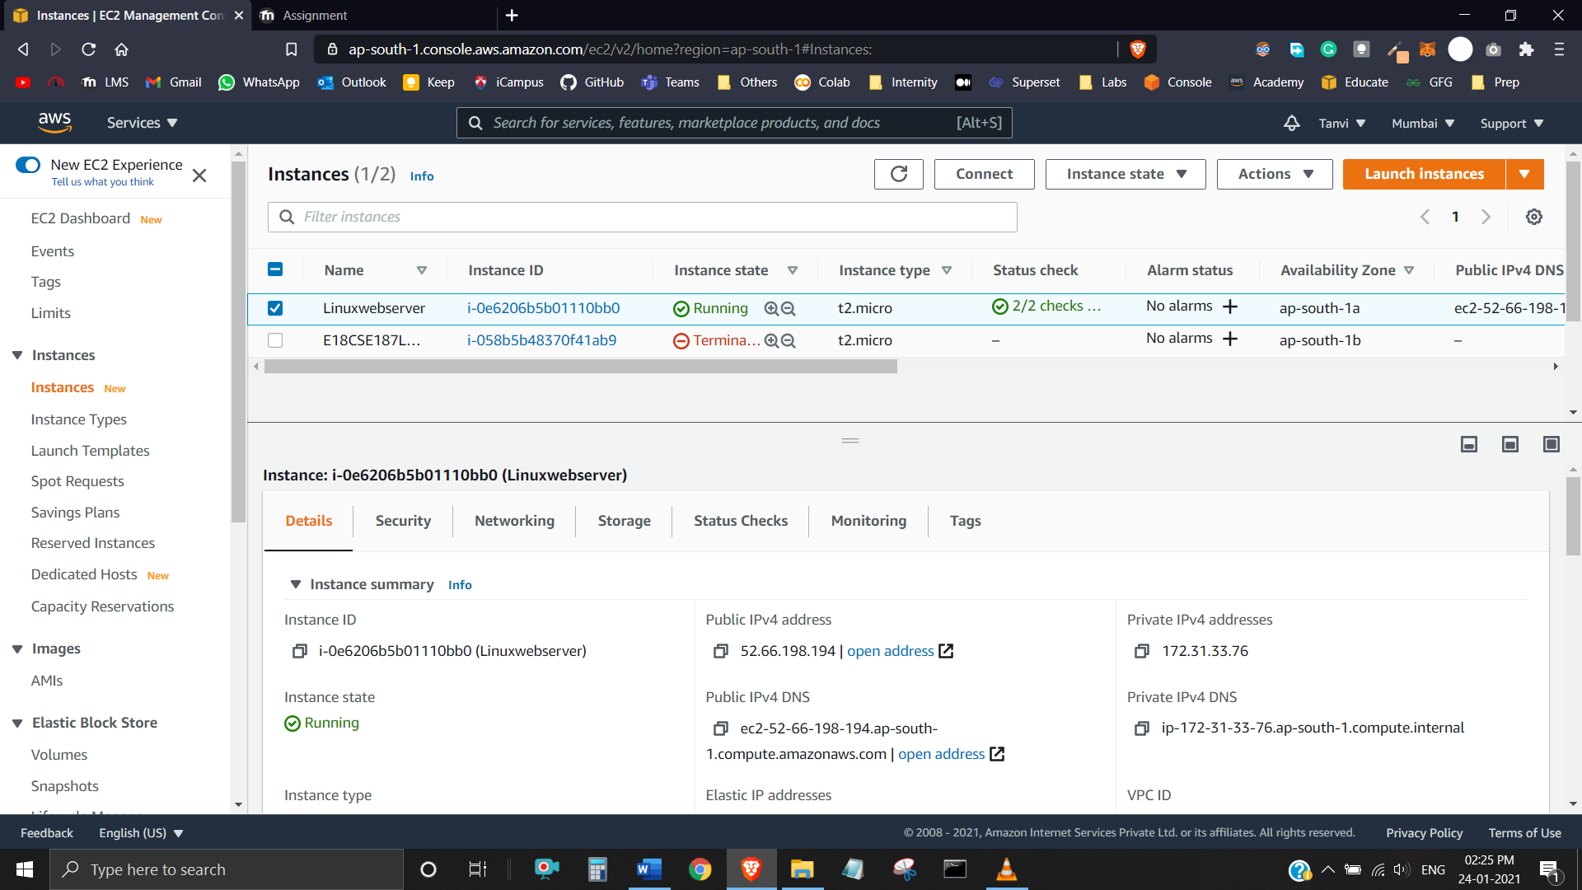

Loading .PEM File and Saving Private Key using PuTTYgen:

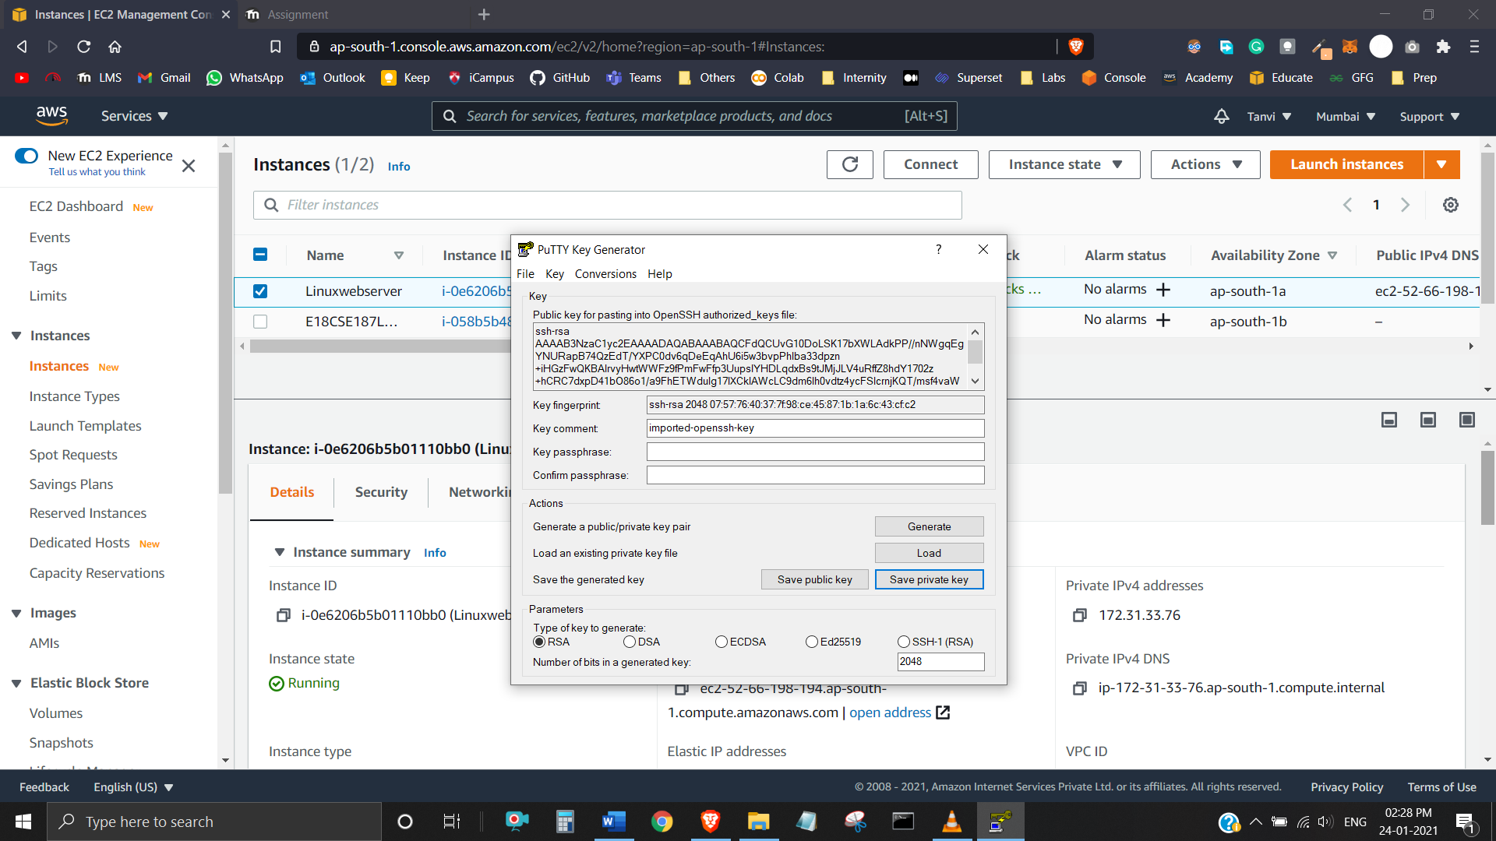

Browsing for Private Key in PuTTY Configure:

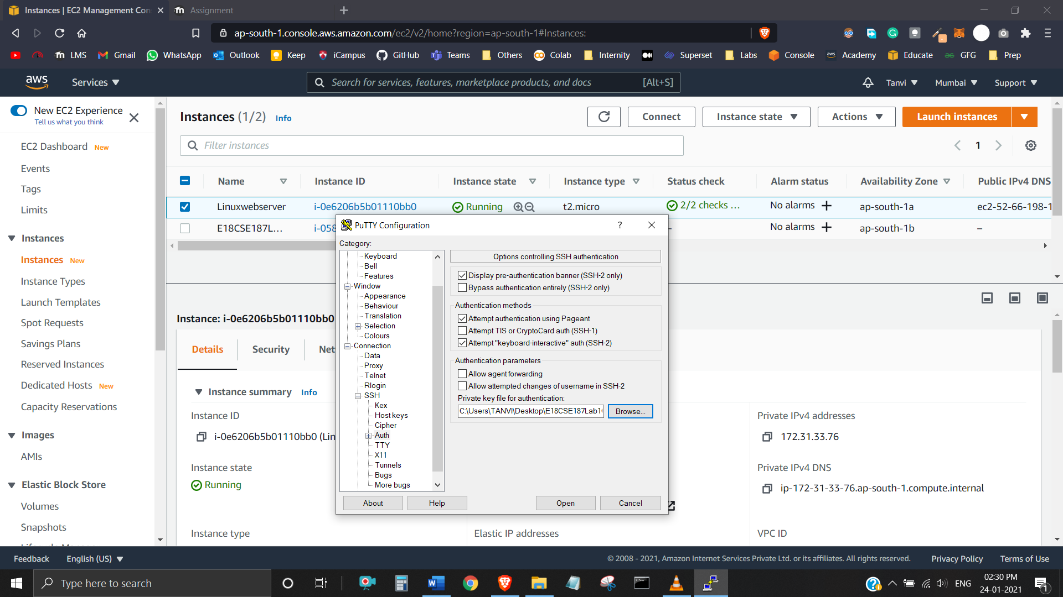

Adding Public IPv4 Address:

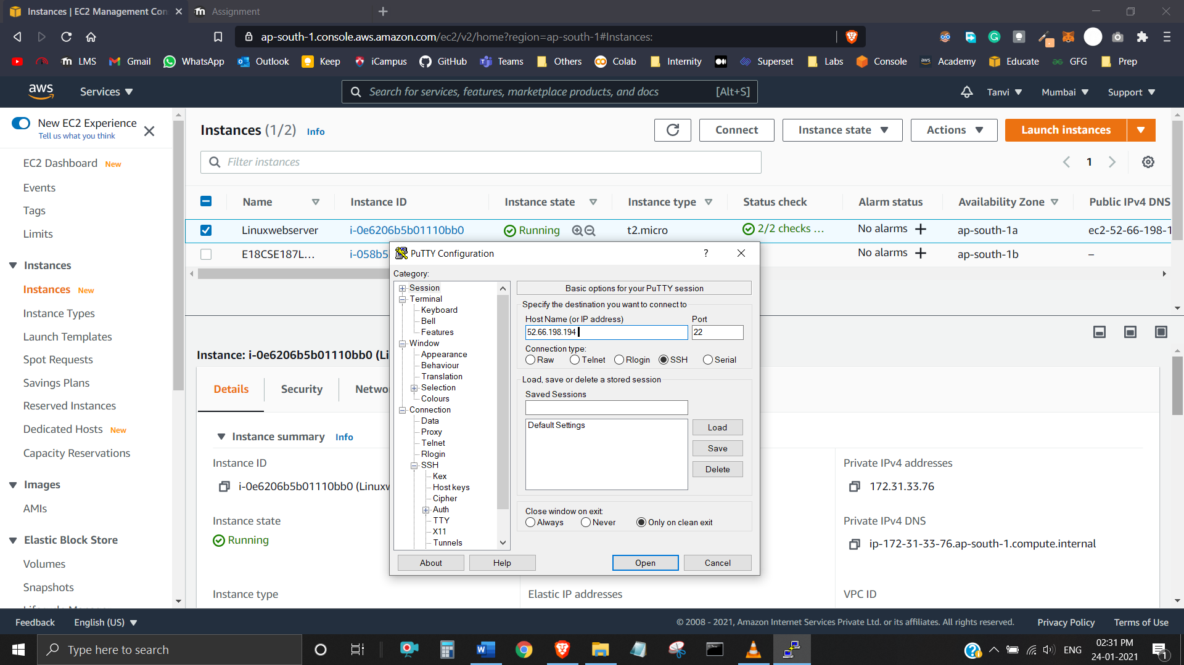

Connected: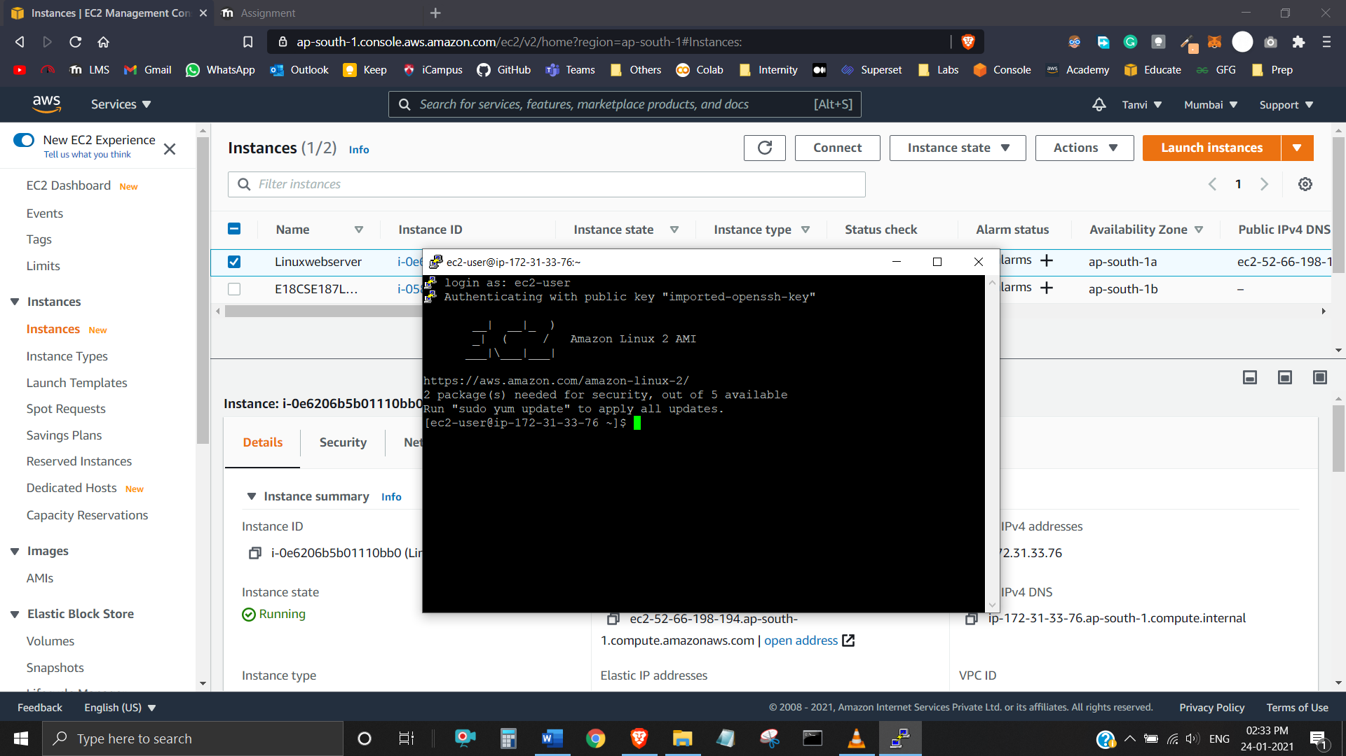

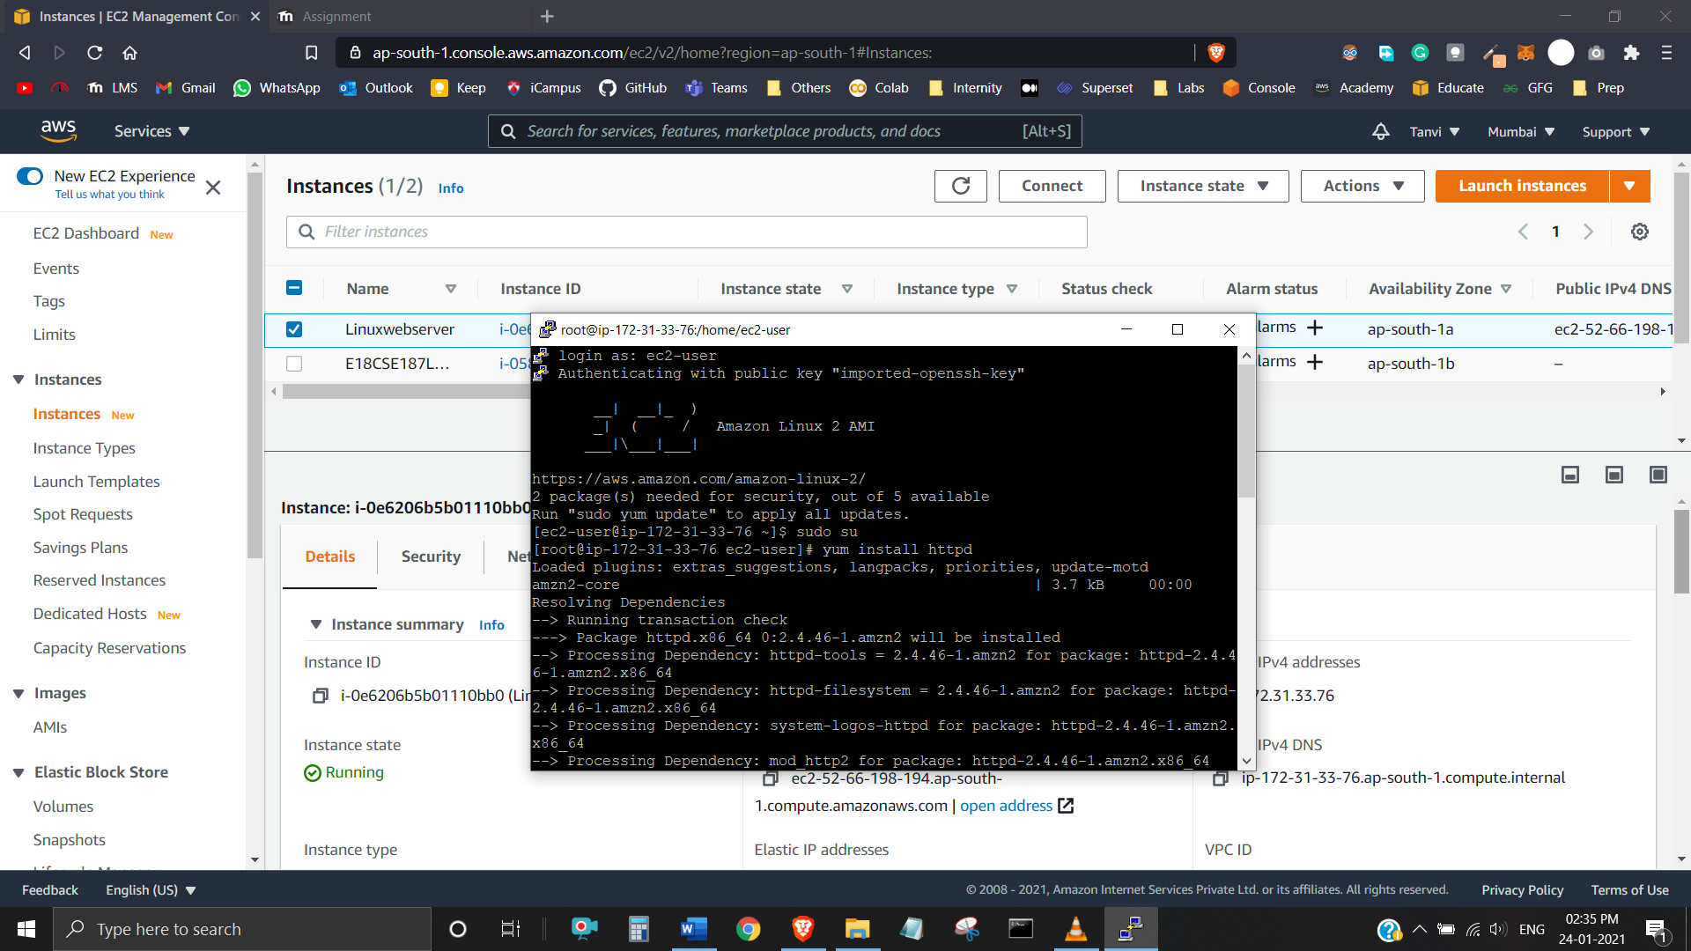

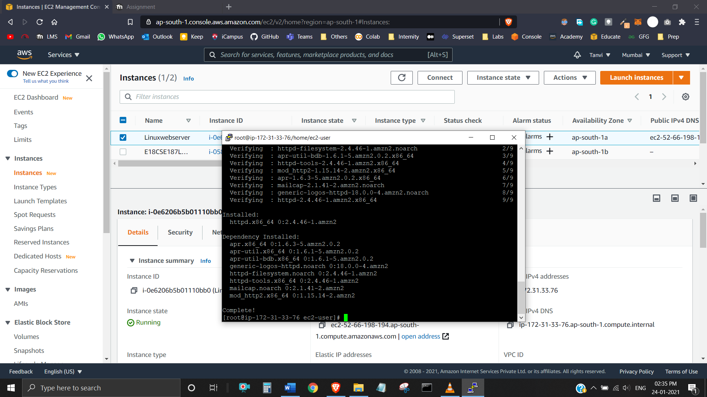

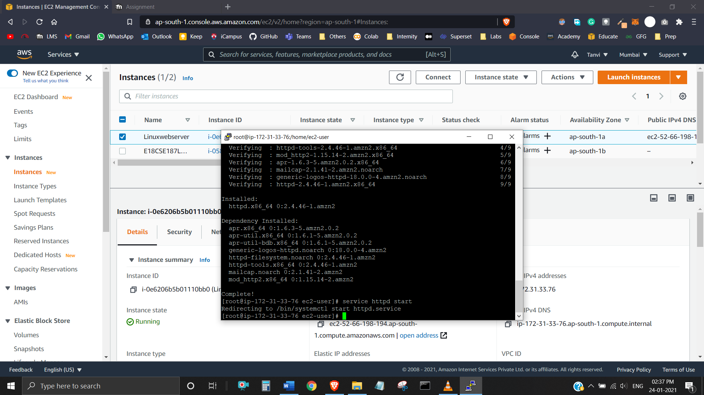

Checking Status: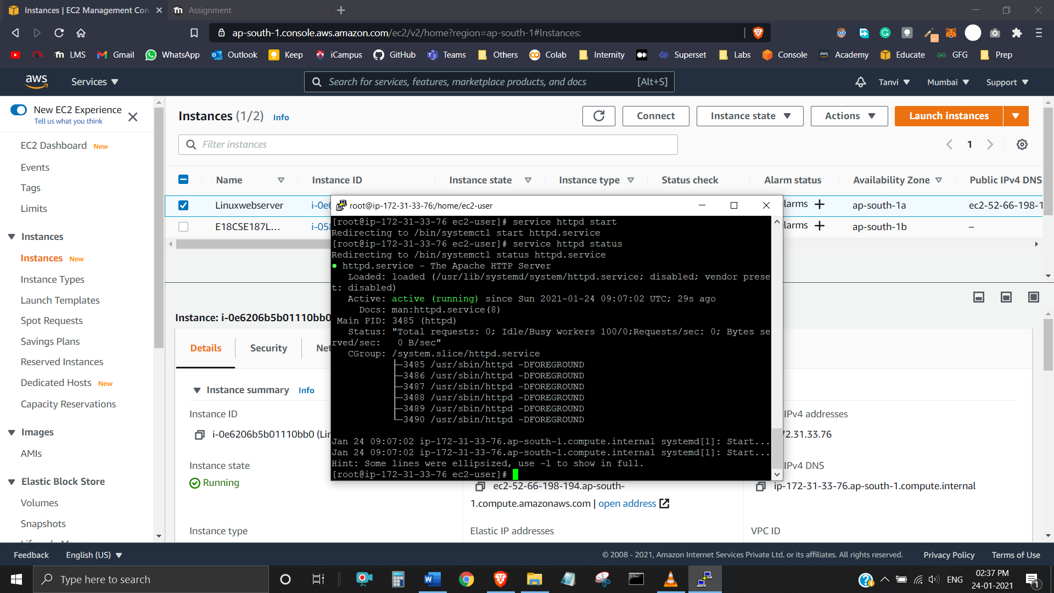

Running on http://52.66.198.194:

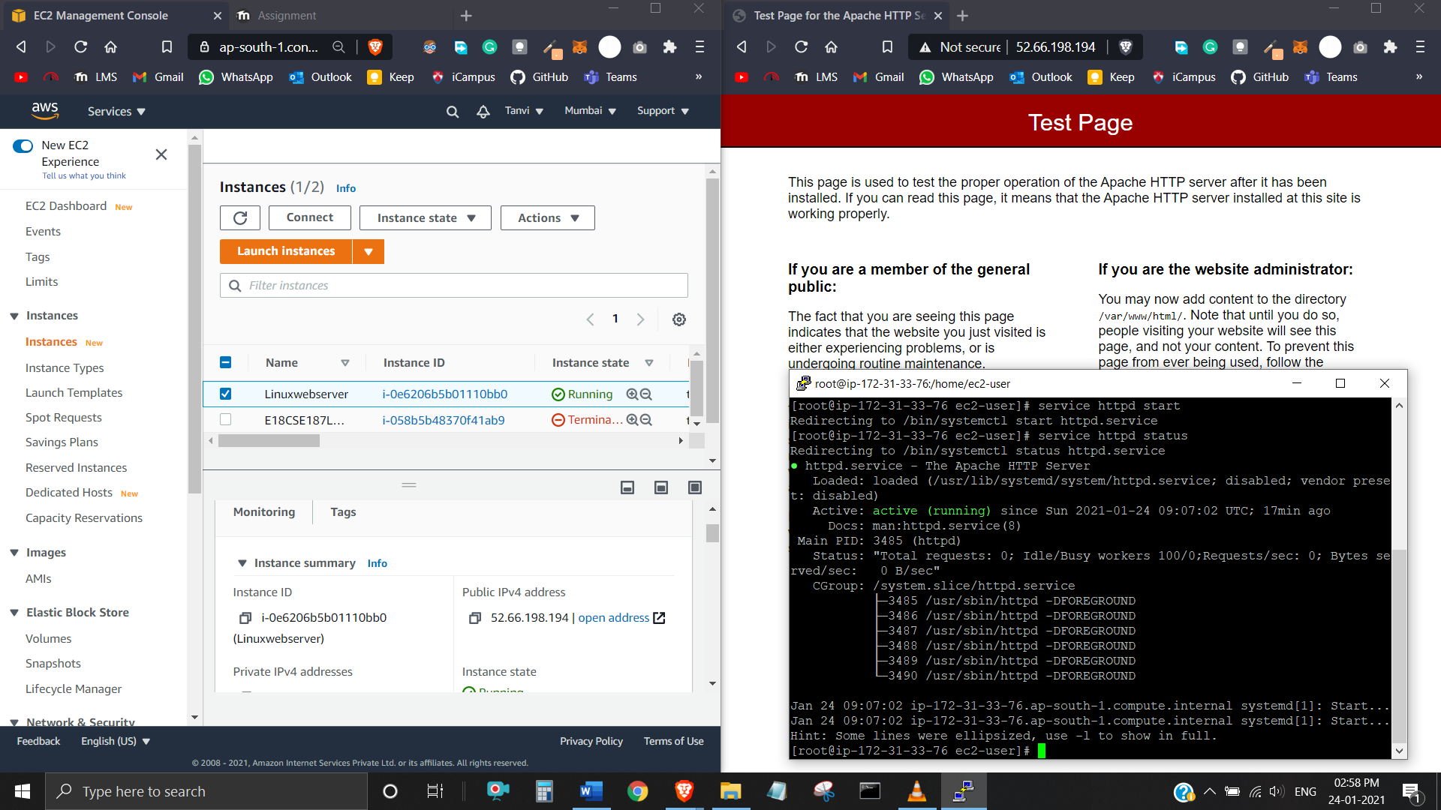

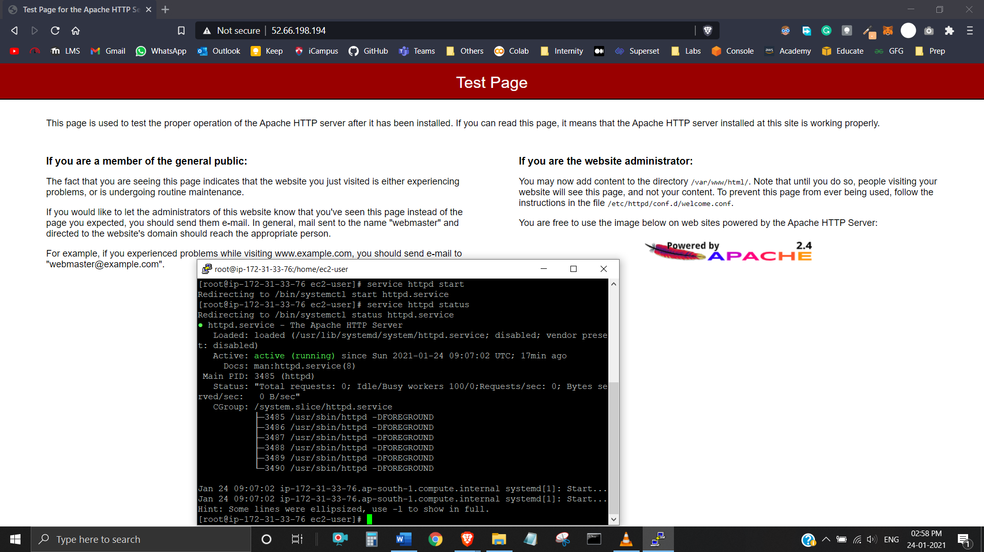

Stopping:

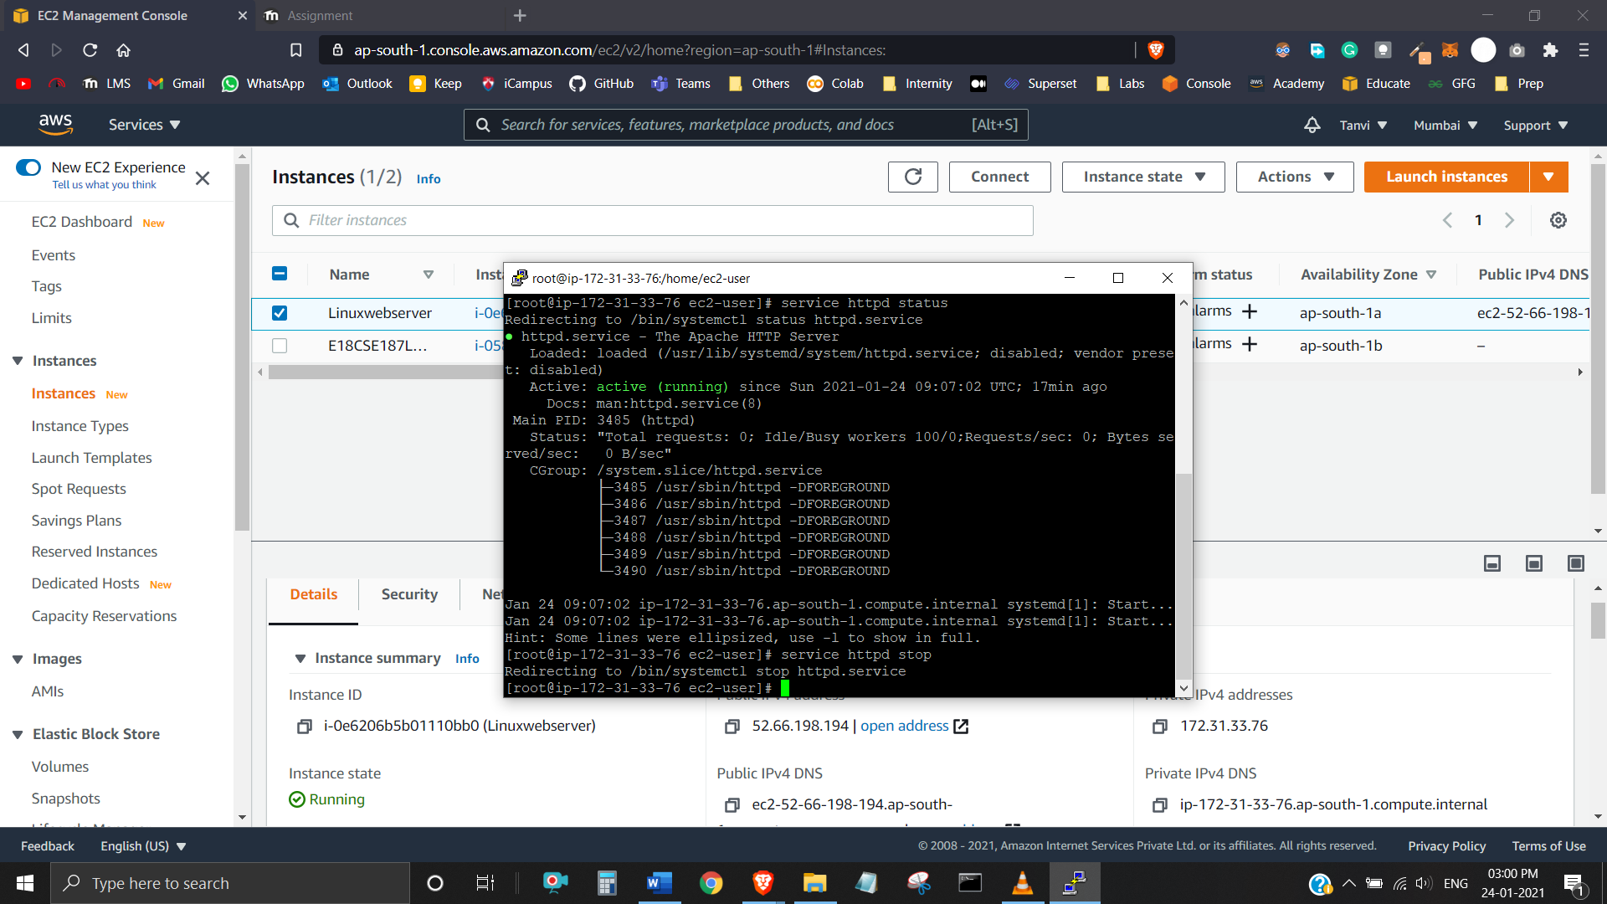

**Lab Activity 2 (On AWS Academy)**

**Task 1:** Explore the Users and Groups

Exploring Users:

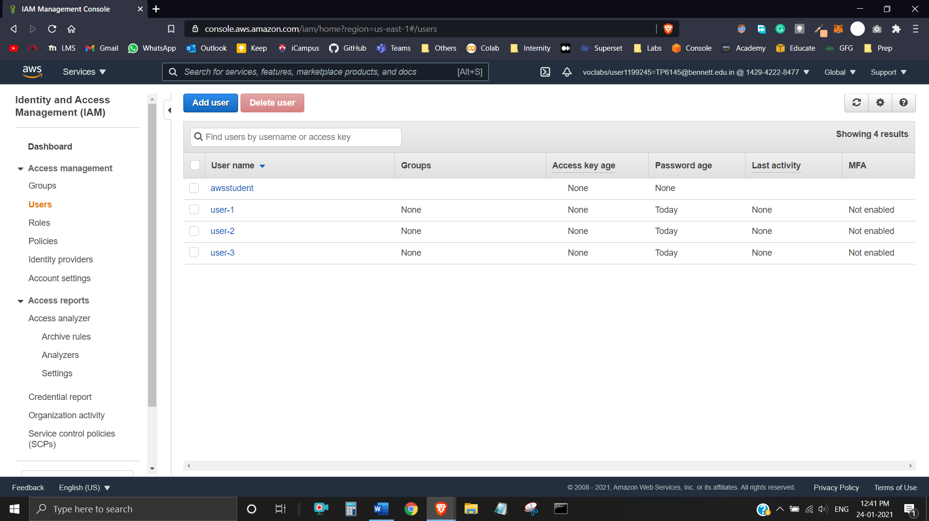

Exploring Groups:

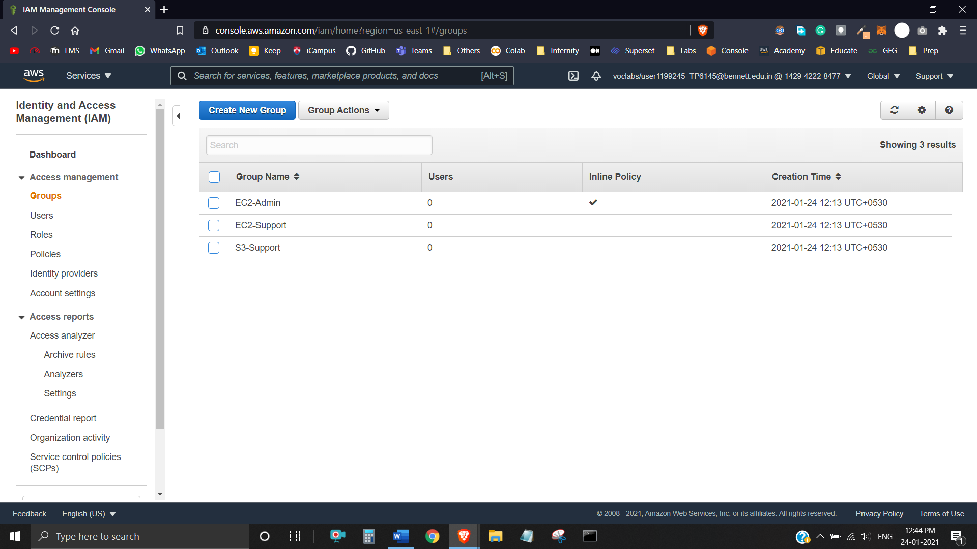

Each user is assigned a Console Password: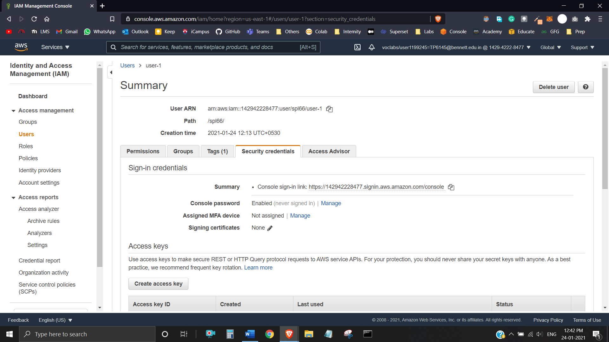

EC2-Admin Group – Has Inline Policy:

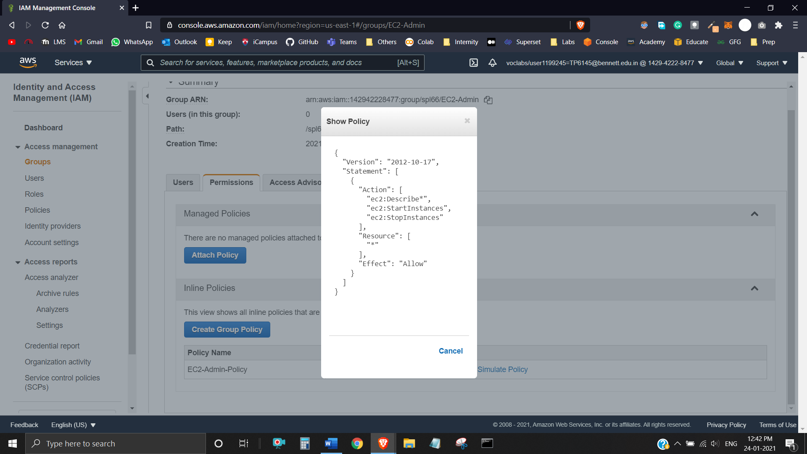

EC2-Support Group – Has Managed Policy (AmazonEC2ReadOnlyAccess):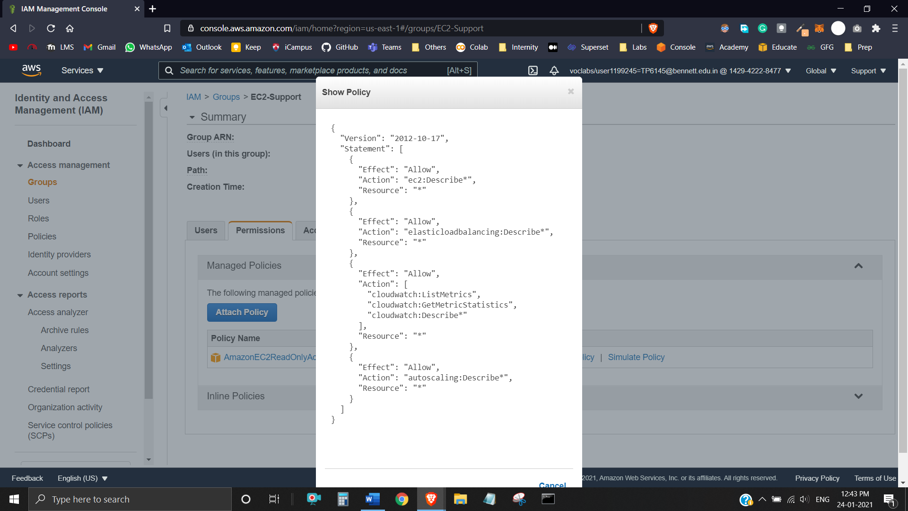

S3-Support group – Has Managed Policy (AmazonS3ReadOnlyAccess):

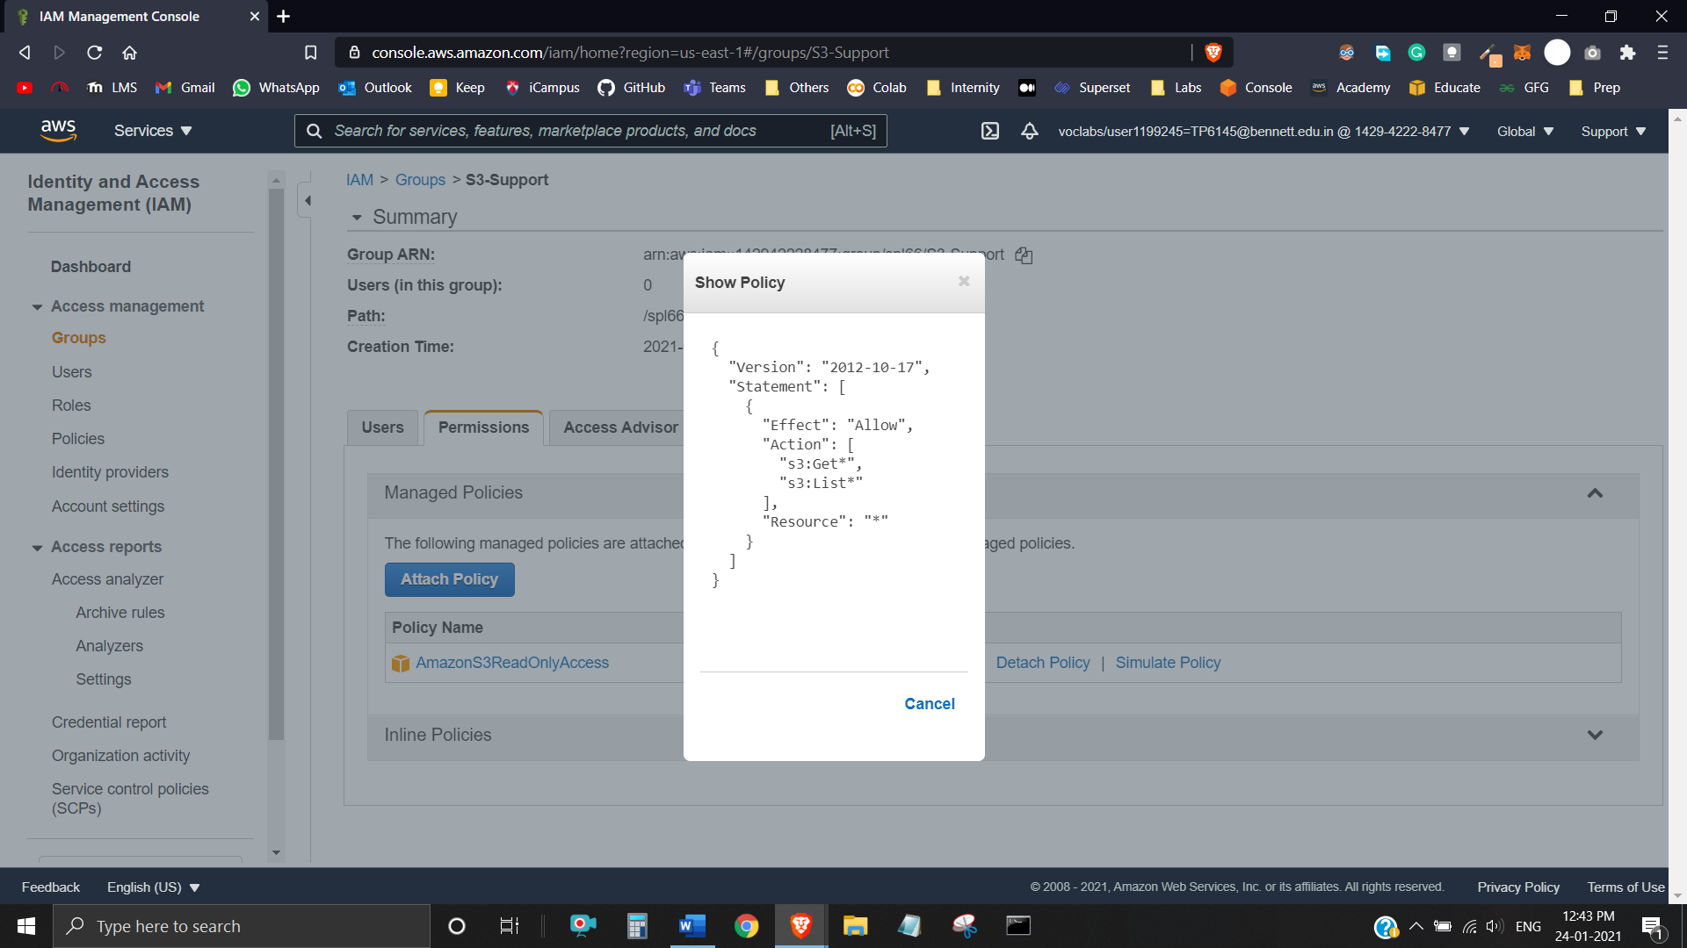

**Task 2:** Add Users to Groups

Added user-1 to S3-Support Group:

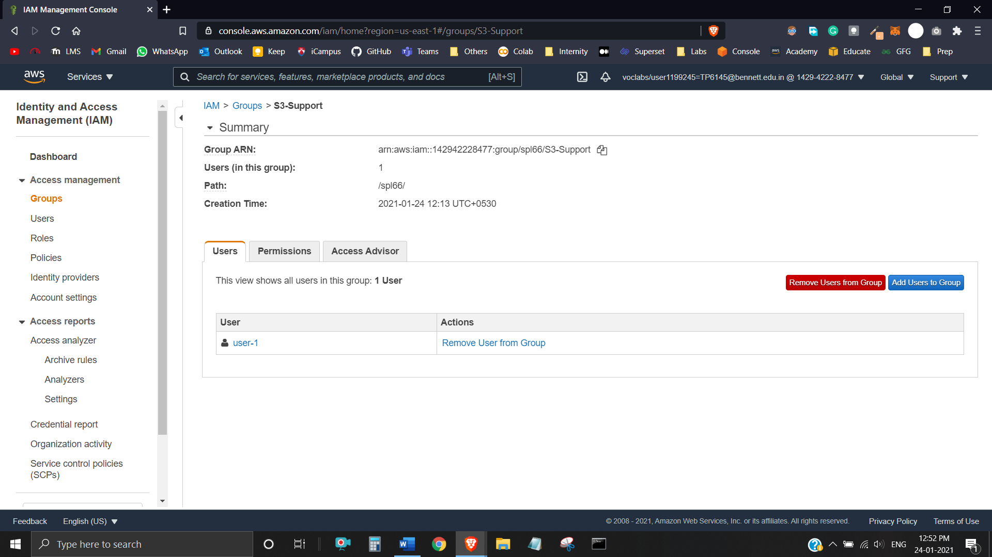

Added user-2 to EC2-Support Group:

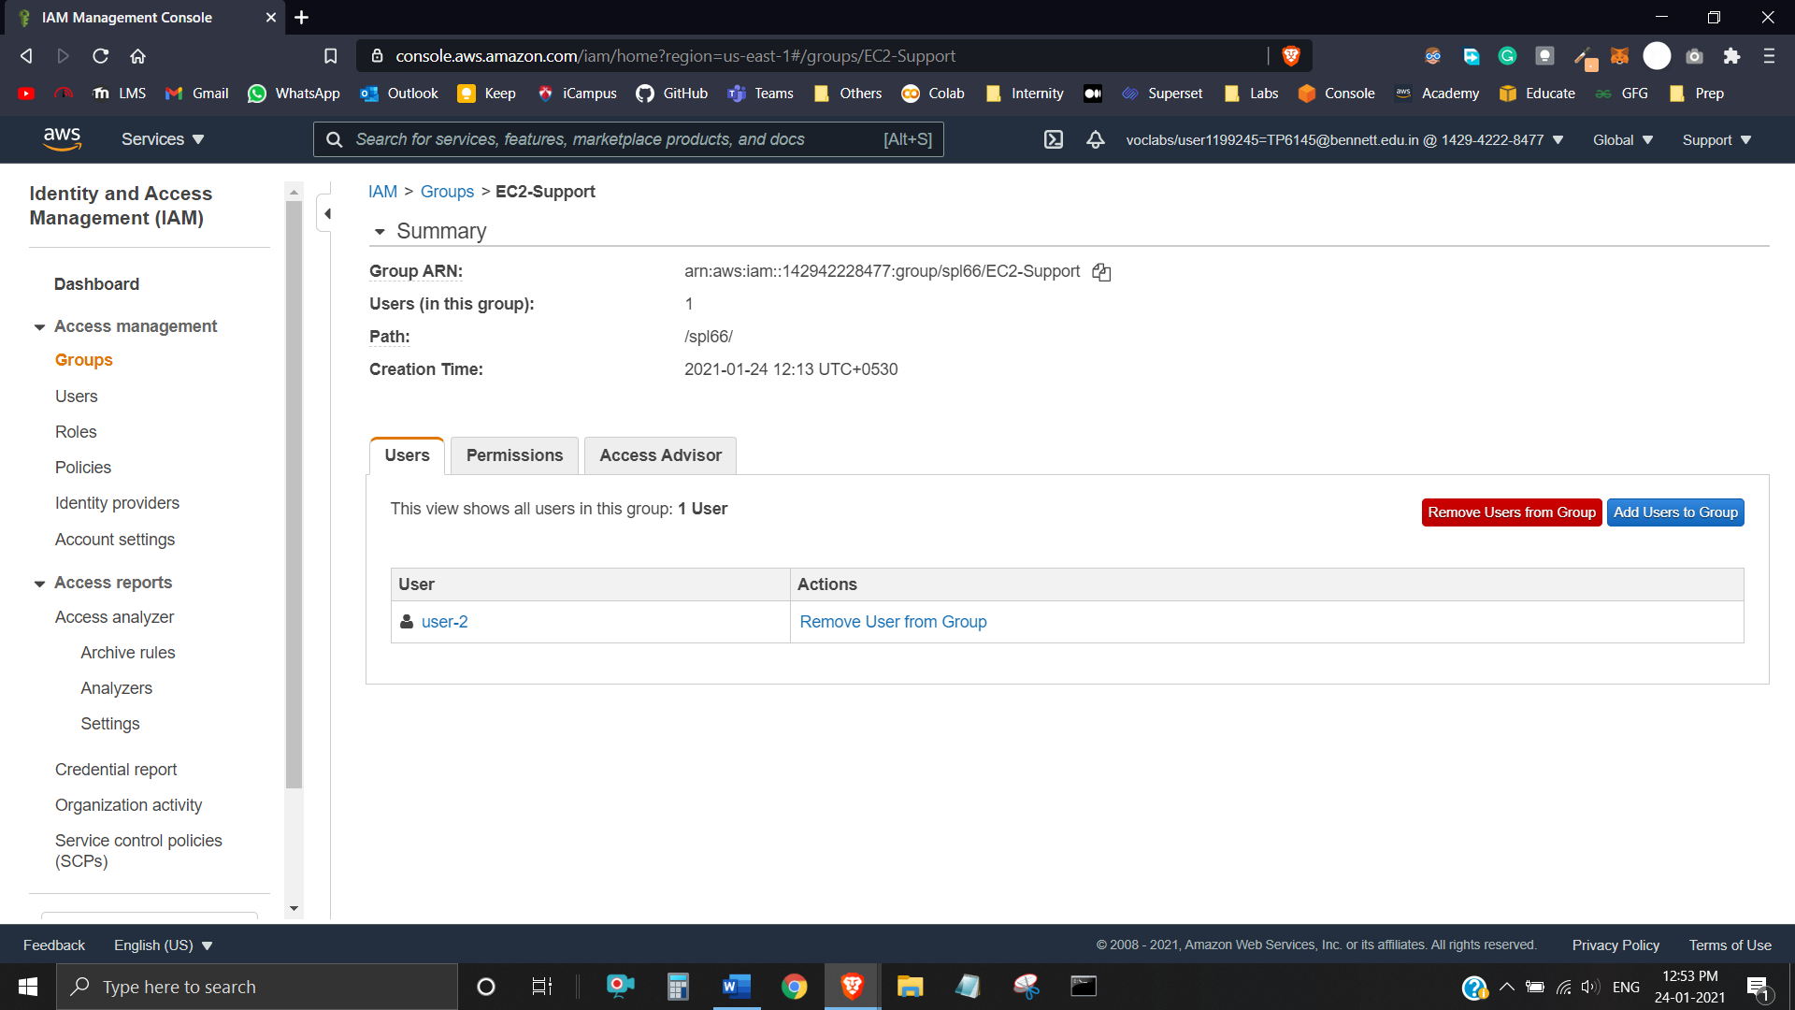

Added user-3 to EC2-Admin Group: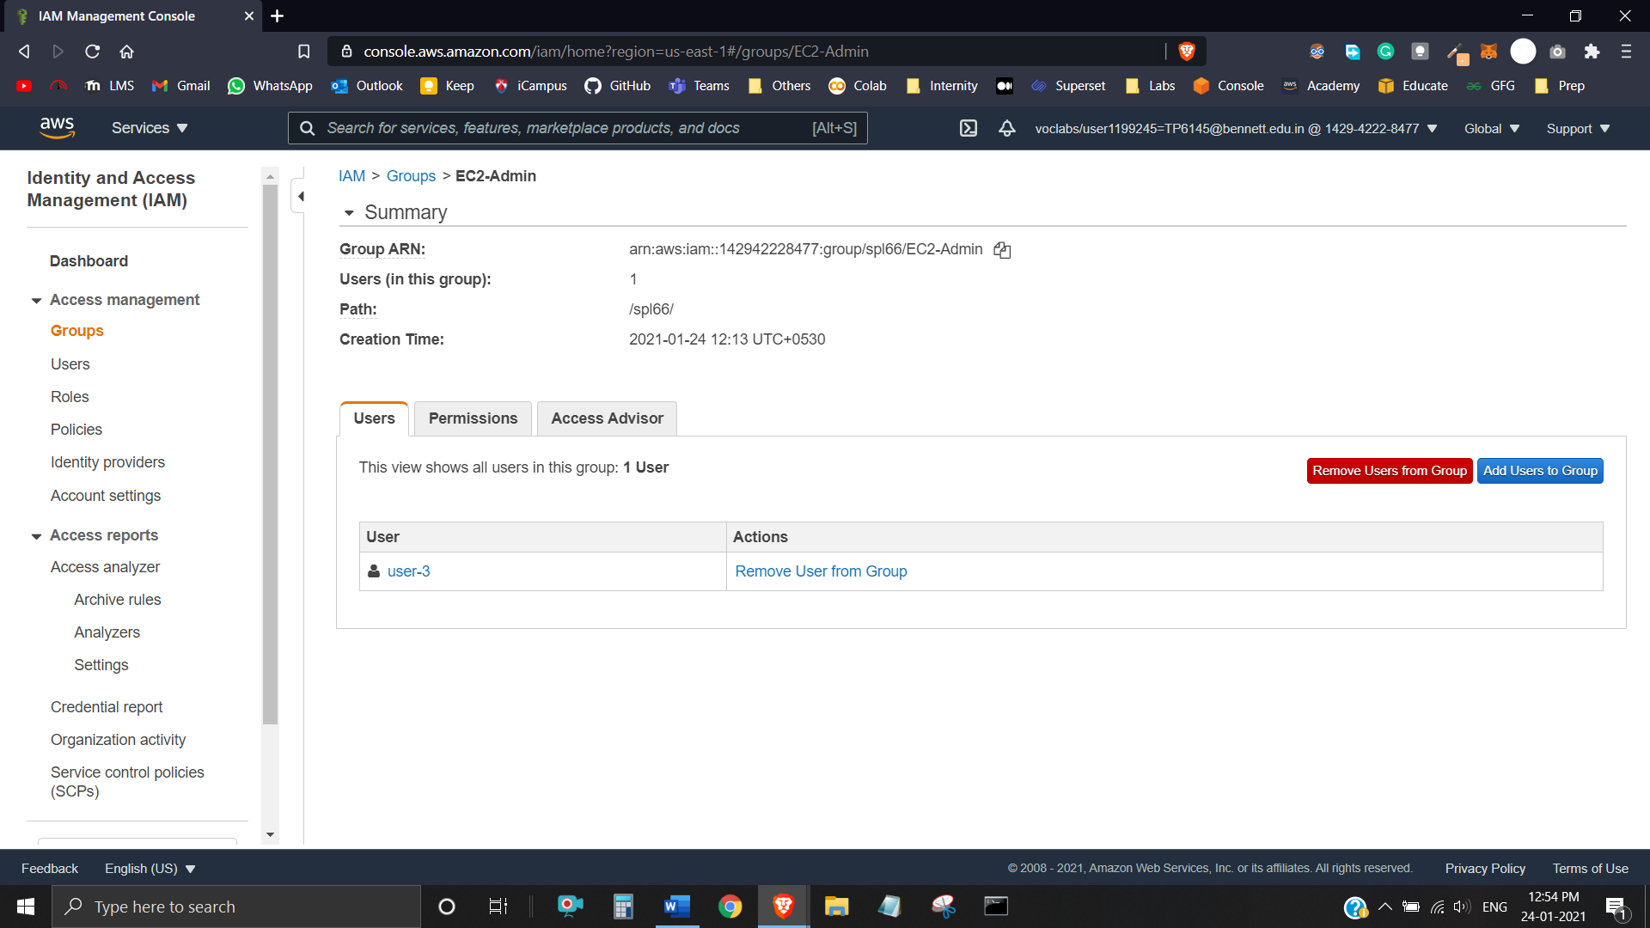

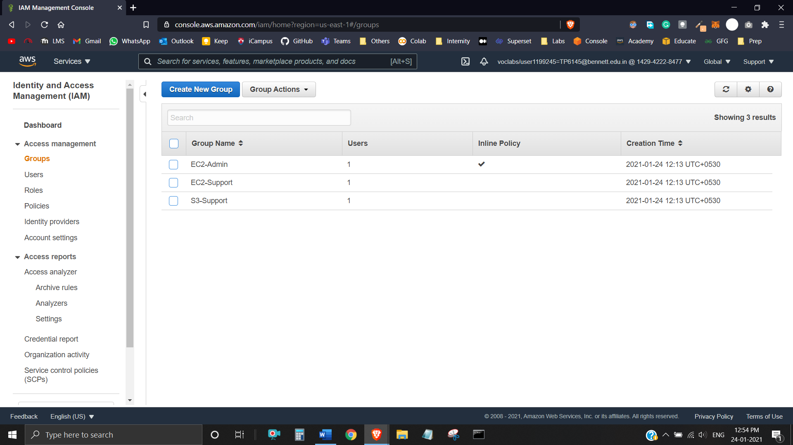

**Task 3:** Sign-In and Test Users

User-1 can view list of Amazon S3 buckets and their contents:

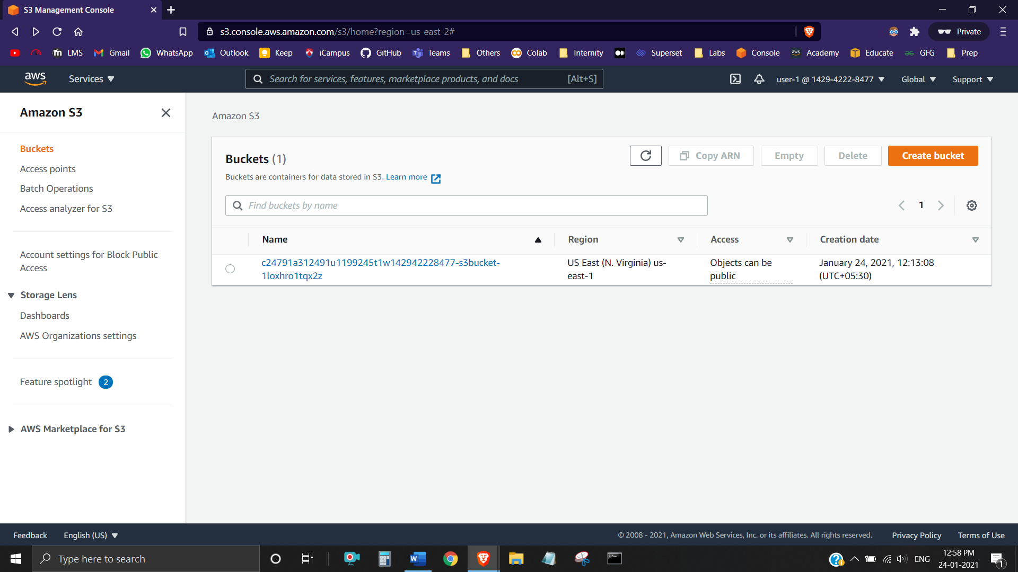

User-1 has not been assigned any permissions to use Amazon EC2:

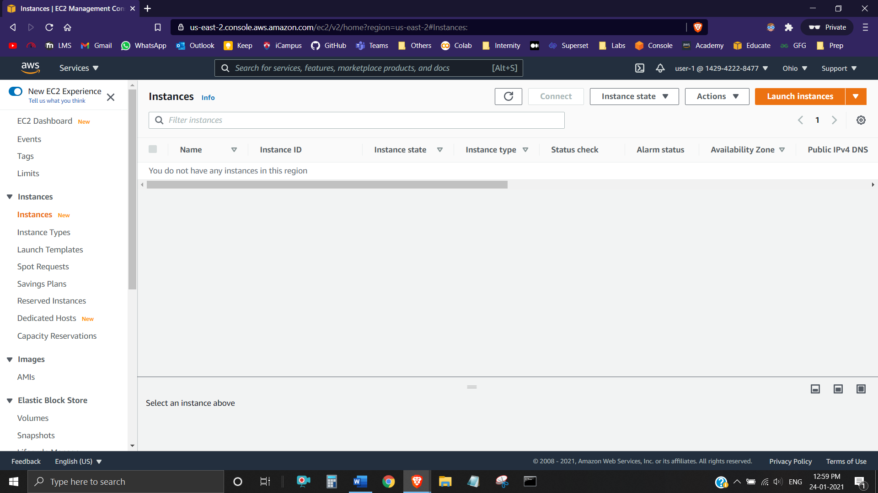

User-2 can view Amazon EC2 Instances since he/she has Read Only Permissions: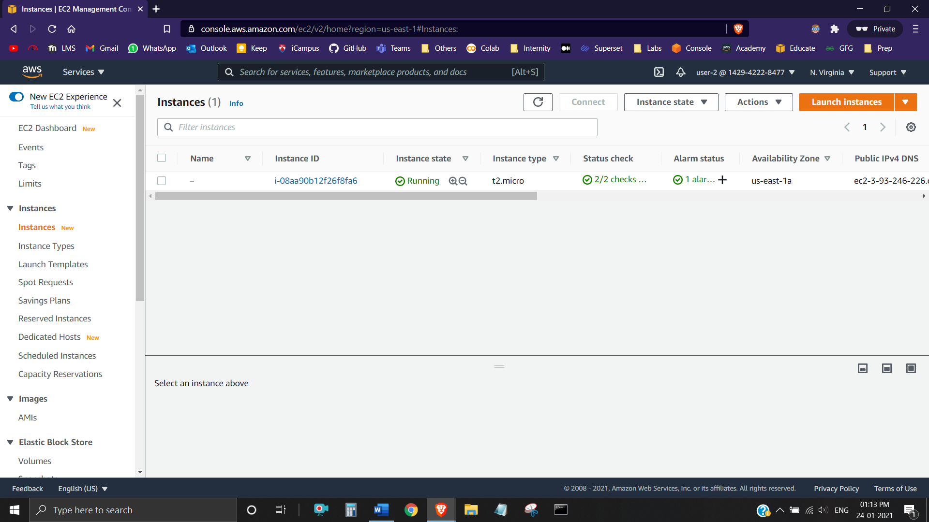

User-2 cannot stop Instance as policy only allows user to view information:

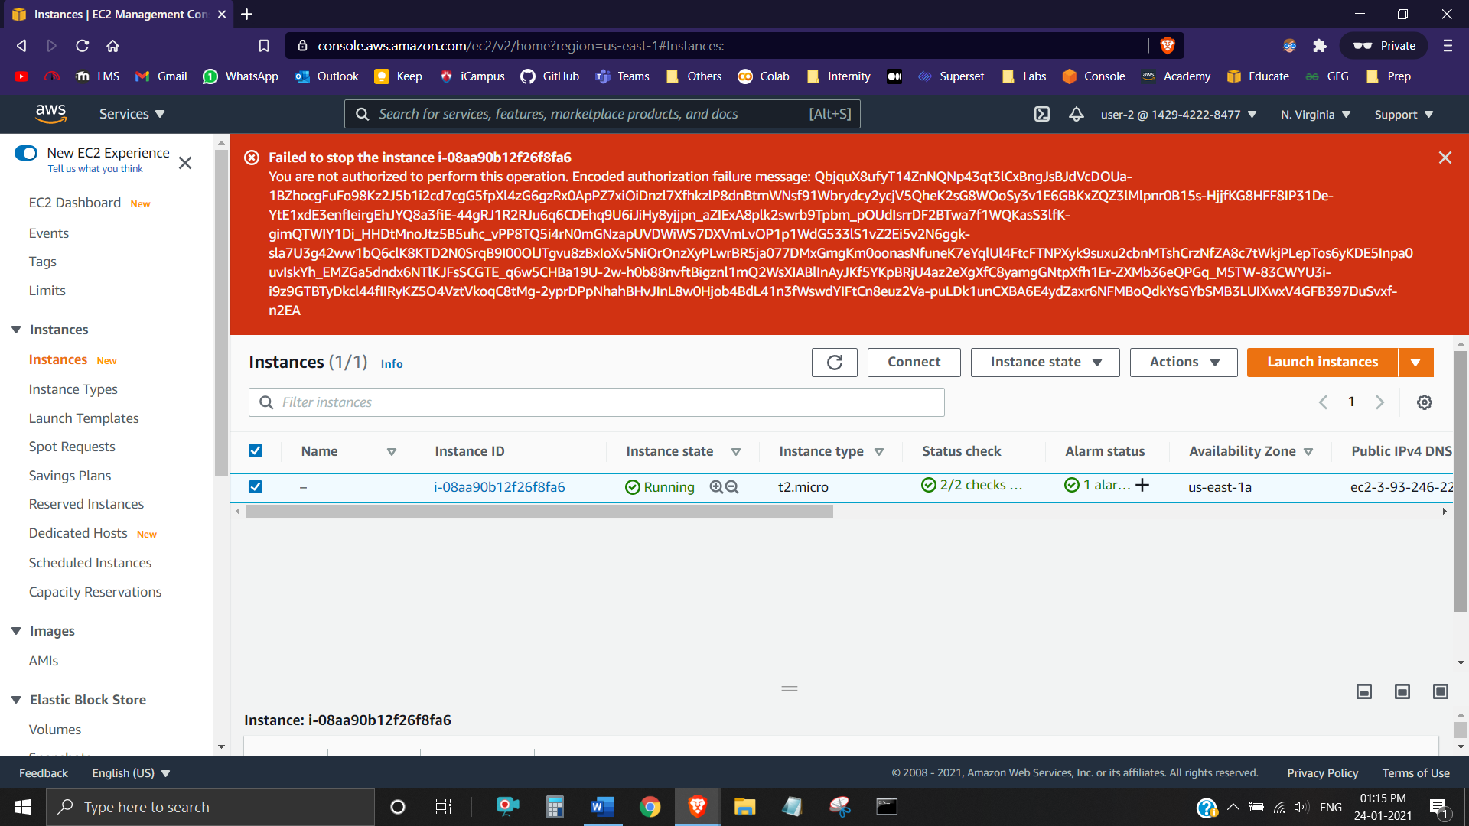

User-2 does not have permission to use Amazon S3: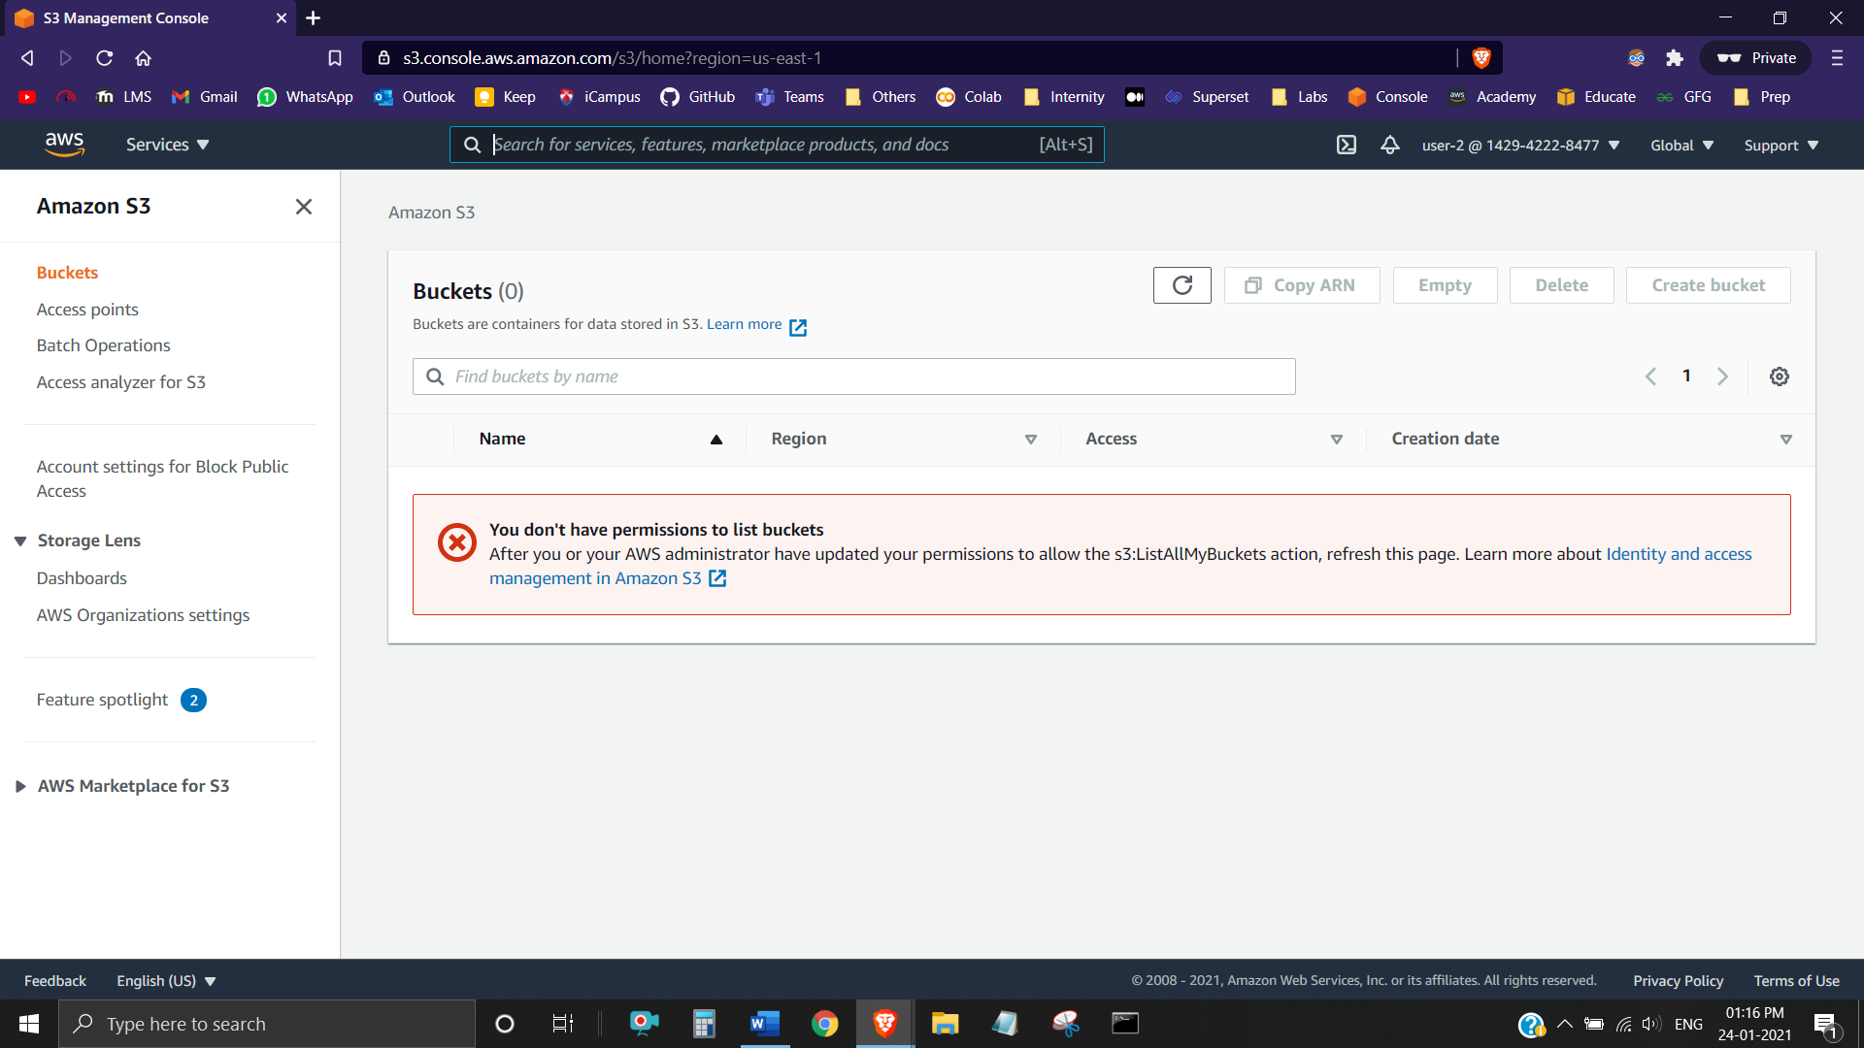

User-3 can view Amazon EC2 Instances:

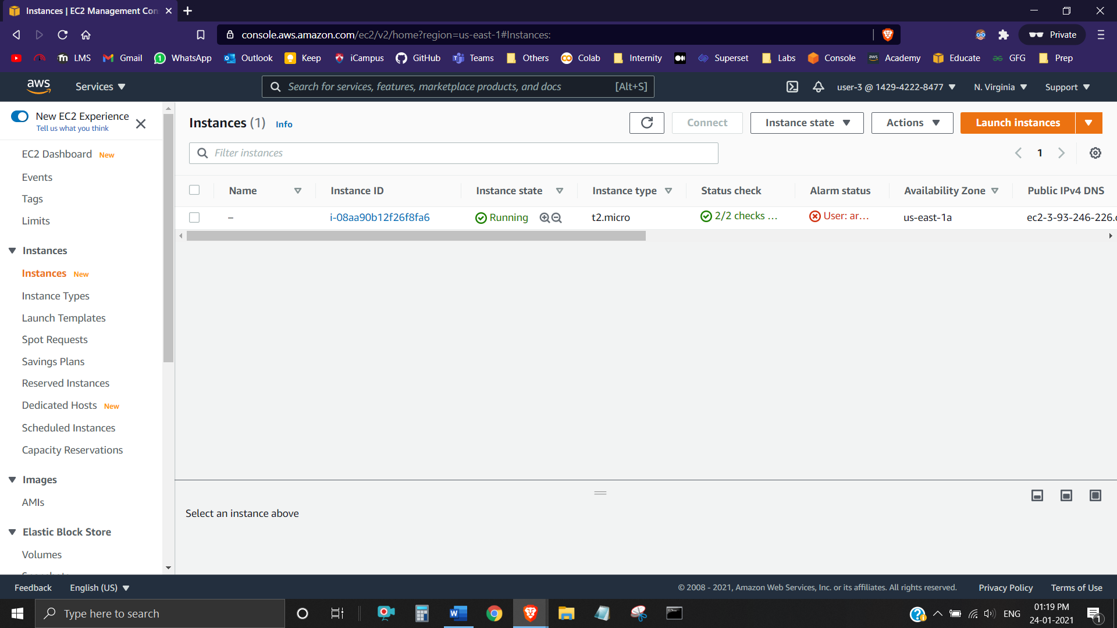

User-3 can stop Amazon EC2 Instances:

